CID 75k User & Installation Guide
Rev 2.0 ● September, 2022

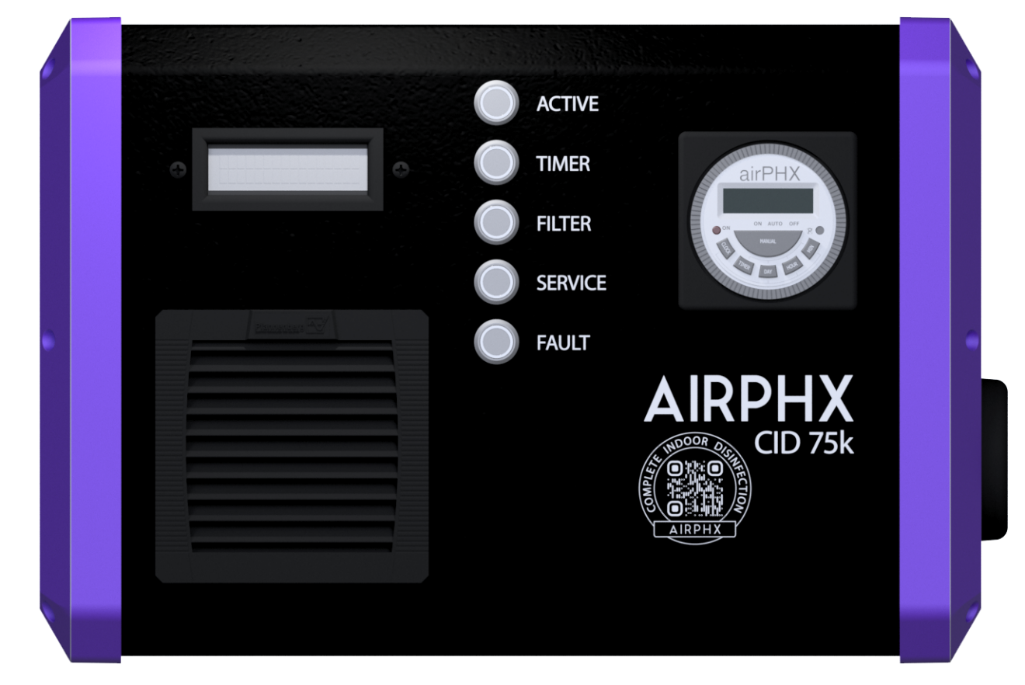
AIRPHX®

1 Pre-Installation Check List
Please check the shipping box that your AIRPHX CID 75k arrived in for damage. If any damage is found, please contact your AIRPHX representative prior to installation 855-424-7749 (855-4 AIRPHX).
- Included in the box
- CID 75k
- Easy mount wall bracket (preinstalled on the unit)
- Mounting hardware
- AC power cord (early versions of the unit only)
- CID 75k Quick Reference Guide
- AIRPHX 7 Day Timer User Guide
- Annual supply of filters
- Welcome card
- Complete Indoor Disinfection decal
- Choose a central mounting location that has good, continuous airflow but is not too close to any strong air supply or return vent. The mounting location should be at least four feet from any adjacent wall and at least twelve inches from the ceiling.
- Check to see if an existing 120-volt outlet is nearby to the location. If not, one may need to be added.
- Do not install the unit near or within areas with high humidity levels.
Specifications
Capacity | 75,000 ft³
Frequency | 50/60 Hz
Nominal Power (W) | 52
Nominal Power (V) | 120VAC
Nominal Power (A) | 0.5
Weight | 9 lbs.
Height | 11 in
Width | 16 in
Depth | 5.5 in
CFM | 40
Please note: Coverage capacity can vary by location based on a number of factors including facility layout, air circulation and bio-burden. Contact an AIRPHX representative to discuss capacity at your particular location.
Contents
1 Pre-Installation Check List 2
2 Notice 5
3 Notice cont. 6
4 Modes of Operation 7
Run Mode: 7
Run Mode switch settings: 7
7 Day Timer Mode: 7
7 Day Timer switch settings: 7
5 Modes of Operation cont. 8
Standby Mode: 8
Conditions that can cause the CID 75k to go into standby: 8
6 Operations & Controls 9
On/Off Switch: 9
Active Indicator: 9
7 Day Timer Switch: 9
Filter Indicator/Switch: 9
Filter Note: 9
7 Operations & Controls cont. 10
Service Indicator/Switch: 10
Fault Indicator/Switch: 10
Example of clearing a fault: 10
7 Operations & Controls cont. 11
Display messages explained: 11
8 Installation Overview 12
The mounting kit contains: 12
9 Installation Overview cont. 13
Provided Parts: 13
Recommended tools: 13
10 Installation Procedure 14
Step by Step Procedure: 14
LCD Display: 14
11 Installation Procedure Fig 1 15
12 Installation Procedure Fig 2 16
13 Filter Replacement and Reset Procedure 17
Filter Location 17
14 Filter Replacement and Reset Procedure cont. 18
15 Filter Replacement and Reset Procedure cont. 19
16 Plasma Chamber Replacement and Reset Procedure 20
17 Plasma Chamber Replacement Process cont. 21
18 Plasma Chamber Replacement Process cont. 22
19 Plasma Chamber Replacement Process cont. 23
20 Q&A 24
21 Q&A cont. 25
Warranty 26
Disclaimer 28

2 Notice
This User & Installation Guide contains basic information for the safe installation and operation of the AIRPHX CID 75k. The operation and installation of this equipment is the sole responsibility of the end-user. Please read this guide in its entirety before installing and operating the equipment.

The AIRPHX CID 75k is intended to provide complete indoor disinfection (CID) in treatment spaces with 75,000 cubic feet. In areas that are significantly smaller, it is recommended that the unit be operated using the timer.
- The AIRPHX CID 75k should never be exposed to liquids. If using cleaning products or liquids near or around the unit, please turn the CID 75k off prior to cleaning.
- Please follow all recommendations for the mounting and installation of the CID 75k unit. If you have any question about the installation, please contact your AIRPHX representative at 855-424-7749.
- Find a central location for the CID 75k within the treatment area.
- Avoid locations with high humidity, like swimming pools, whirlpools, and showers. High moisture levels can damage the CID 75k’s plasma chamber.
- Mount the unit at least four feet from an adjacent wall, and twelve inches from the ceiling. For Americans with Disabilities Act compliance, it is recommended that the unit be mounted with the base at least 80 inches from the floor.
- The CID 75k requires a standard 120-volt outlet. Please verify the following electrical requirements prior to the installation of the CID 75k unit.
- Verify the voltage of the outlet. The CID 75k requires a standard 120- volt outlet with a ground and draws only 1/2 amp, therefore it can be part of an existing circuit.
- If a new outlet is installed, please make certain that the outlet meets all local, state, and national electrical codes.
- Verify that the outlet is not part of a circuit that may be overloaded. Large power fluctuations associated with overloaded circuits can damage the CID 75k.
- Do not use a cord adapter that defeats the earth ground on the provided power cord.

3 Notice cont.

- The filter on the CID 75k generally needs to be replaced every 30 days unless otherwise specified. There is a Filter LED Indicator, located on the front of the unit, that will illuminate red as a reminder to change the filter. Depending on the environment in the treatment space, it is possible that filter may need to be changed more or less frequently. When the Filter LED indicates that it is time to change the filter, remove the filter and hold it up to the light. If light can easily be seen through the filter, it can be used for another 30 days.
- The AIRPHX CID 75k is designed to be mounted on a wall using the included mounting hardware.
- To protect against injury, all repairs to the CID 75k must be performed by qualified service personnel. Please contact your AIRPHX representative with any service request.
- Do not open the CID 75k for any reason. Doing so may put you at risk of injury and will void the warranty.
- If there is an issue with the unit, please contact your AIRPHX representative.
- Do not introduce foreign objects into the unit’s intake or exhaust ports.
- Keep the air inlet and exhaust of the CID 75k clear of obstructions.

Additional filter and replacement plasma chambers can be purchased from our online store. Please contact your AIRPHX representative at 855-424-7749 or visit our online store - https://www.airphx.com/shop

If further assistance is required, please contact your AIRPHX representative at 855- 424-7749 or visit our website https://www.airphx.com/FAQs, where additional information can be found including user guides as well as helpful videos.

4 Modes of Operation
The CID 75k has three modes of operation.

Run Mode: In this mode of operation the CID 75k will run continuously. The Active LED will illuminate green.

Run Mode switch settings:
- The power switch, located on the left side of the unit, is in the ON position (Switch Indicator will illuminate red).
- The 7 Day Timer switch is in the OFF position and its LED is not illuminated.
7 Day Timer Mode: In this mode of operation, the CID 75k will be controlled by the schedule that has been programmed into the 7 Day Timer. The 7 Day Timer mode is ideal for small areas of treatment and applications where you may want to run the unit at specific times and days. As example, night only.

7 Day Timer switch settings:
- Both the power and the 7 Day Timer switches are in the ON position.
- The Timer Switch LED will be illuminated green. The Active LED will illuminate green when in a scheduled run period.

5 Modes of Operation cont.
Standby Mode: In standby mode, the CID 75k is powered on but both the plasma chamber and the unit turbine are off.

Conditions that can cause the CID 75k to go into standby:
- The filter has not been checked within 15 days of the Filter LED Indicator illuminating red. At this point, the filter will need to be checked and changed if dirty and the filter reset procedure must be performed. Please refer to the section in this guide, Filter Replacement and Reset Procedure for more details.
- The unit has been in operation for a year and it is time to replace the plasma chamber. In this situation, the Service LED will illuminate red indicating it is time to service the unit.
- The CID 75k 7 Day Timer is enabled, and an off-schedule program is running.
- The fault monitoring circuit has detected a fault with the CID 75k. In that case, the Fault LED will illuminate red, and a fault message will be displayed on the LED screen located on the front of the unit. Please refer to the section in this guide, Fault Indicator for more details.
In all conditions, the unit will resume operations once the condition is cleared.

6 Operations & Controls

On/Off Switch:
The On/Off switch controls the on/off function of the CID 75k. This switch is located on the left side of the unit and will illuminate red once pressed, turning the CID 75k on.

Active Indicator:
The Active Indicator will illuminate green whenever the plasma chamber is active, and the unit is producing disinfecting molecules. The Active Indicator will illuminate red if a fault has been detected within the plasma chamber.

7 Day Timer Switch:
The 7 Day Timer LED switch controls the on/off function of the 7 Day Timer. The switch will illuminate green once pressed, turning the timer on. Once on, the operation of the CID 75k is controlled by schedules programmed into the 7 Day Timer. During an off-schedule program, the unit will go into standby awaiting an on-schedule program to resume and the Active LED will not be illuminated.

Filter Indicator/Switch:
The Filter Indicator will illuminate green when the CID 75k is first turned on and remain green for 30 days of operation. At 30 days of operation, the Filter Indicator will illuminate red as a reminder to check the unit’s intake filter and change if dirty.

Filter Note:
If the filter is not checked within 15 days of the Filter Indictor illuminating red, the unit will go into standby mode until the filter is checked and changed if dirty, and the filter reset procedure is completed. Please refer to the Filter Replacement and Reset Procedure section in this guide for further details and instructions.

7 Operations & Controls cont.

Service Indicator/Switch:
The Service Indicator will illuminate green when the CID 75k is first turned on and remain green for 1 year of operation. At the end of a year of operation, the Service Indicator will illuminate red as a reminder to change the unit’s plasma chamber. Please refer to the section in this guide Plasma Chamber Replacement and Reset Procedure for further details.

Fault Indicator/Switch:
The Fault Indicator will illuminate red when a fault has been detected within the CID 75k. Details about the fault will be displayed on the unit’s LCD display location on the front of the unit. Some faults can be reset after they have been cleared by pressing the Fault Indicator button.

Example of clearing a fault:
Removing the plasma chamber exhaust grill while the unit is powered will cause a fault. To clear this fault, the grill must first be reinstalled, and the Fault LED button must be pressed. Please note that the fault will remain if the reset button is pressed while the grill is still off.
In the case of a fault that does not clear, it is recommended that you power off the unit and contact your AIRPHX representative for further assistance.

7 Operations & Controls cont.

Display messages explained:

Displayed message - System Status Normal.
Explanation - The unit is operating normally.
Unit status – Normal

Displayed message - Plasma Chamber Grill Open.
Explanation - The plasma chamber grill has been removed or is loose.
Unit status – The unit will be in a fault condition and in standby mode.
Reinstalling or tightening the plasma chamber grill and then resetting the Fault LED should clear the fault.

Displayed message - Plasma Chamber Power Failure.
Explanation - The power supply for the plasma chamber has a failure.
Unit status – The unit will be in a fault condition and in standby mode.

Displayed message - Plasma Chamber Fan Failure.
Explanation - The fan that cools the plasma chamber power supply has failed.
Unit status - The unit will be in a fault condition and in standby mode.

Displayed message - Enclosure Fan Failure.
Explanation - The fan that supplies air to the plasma chamber has failed.
Unit status - The unit will be in a fault condition and in standby mode.

In the case of a fault that does not clear, it is recommended that you power off the unit and contact your AIRPHX representative for further assistance.

8 Installation Overview
The CID 75k mounts to a wall utilizing a small two-piece Vesa mount (provided). The mount comes preinstalled on the CID 75k. To install the wall mount section of the Vesa mount, you must first remove the wall mount section from the back of the unit. This is done be separating the two halves of the mount. To separate the two halves, you must first remove the two Phillips screws located on the bottom of the bracket.

The mounting kit contains:
- Wall Mount Bracket (already attached to the unit).
- Four enclosure Threaded Anchors
- Four Phillips Screws
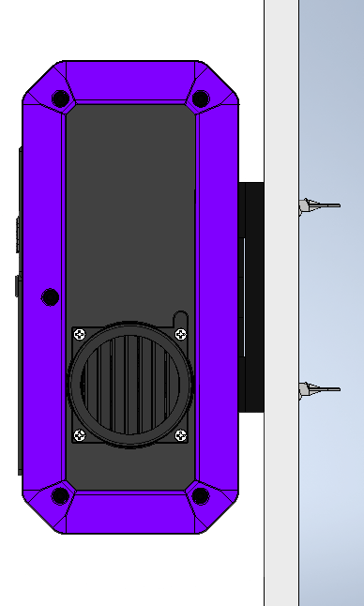
CID 75k
Wall Mount Bracket
Wall
Threaded Anchors

9 Installation Overview cont.

Provided Parts:
- Vesa Mount
- 4 Self Drilling Threaded Drywall Anchors
- 4 Phillips Screws

Recommended tools:
- Level
- Pencil
- Long Phillips Screwdriver
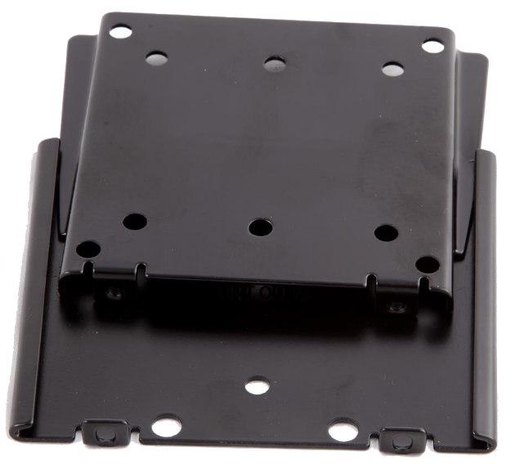
- Punch or Scratch Awl
Wall Mount Section
Phillips Locking Screws
Top of Mount
CID 75k Mount
Section
Preinstalled on the CID 75k

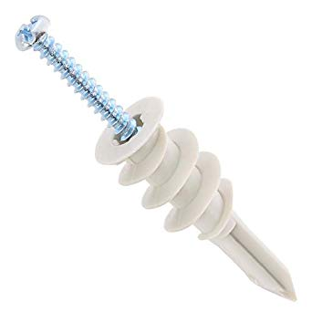
Drilling Threaded Drywall Anchor
Phillips Screw

Note: The wall mount for your unit may vary from the one shown here.

10 Installation Procedure

Step by Step Procedure:
In the example below, Threaded anchors are used to mount the CID 75k to drywall.
- Find a central location for the CID 75k within the treatment area. Be mindful of any obstructions that may be within the wall.
- Remove the wall mount section of the Vesa mount that came preinstalled on the back of the CID 75k. This is done by removing the two Phillips screws located on the bottom of the bracket as seen in Fig 1.
- Place the wall section of the mount against the wall.
- Using a level, level the bracket and mark four of the smaller holes. It does not matter if you use the four inner or outer holes.
- The Threaded Anchors are designed to self-drill into drywall using a Phillips screwdriver. It may be easier to start the anchor if you make a small hole first using a Scratch Awl.
- Screw the anchors in all the way until the outer rim of the anchor is flush with the drywall.
- Using a Phillips screwdriver, place all four screws through the wall mount section and then into each anchor. Tighten all four screws until they a snug. Be certain to use a level during the final tightening process to ensure the mount is level.
- Once the mount is secured to the wall, align the section of the mount on the back of the CID 75k so that it slides down from the top onto the section of the mount that is mounted on the wall as shown in Fig 2. The CID 75k will slide down onto the wall mounted section from the top.
- The installation is complete. The CID 75k can be plugged in and turned on.

LCD Display:
If upon installation the LCD Display is blank, with the unit powered on, please press the Fault Indicator to initiate display mode.

11 Installation Procedure Fig 1

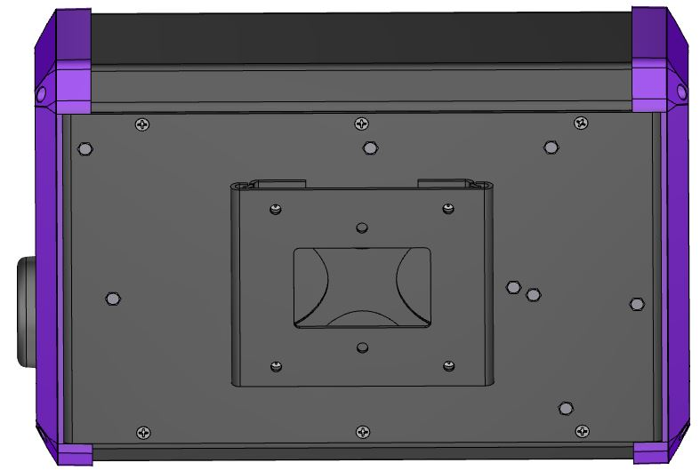
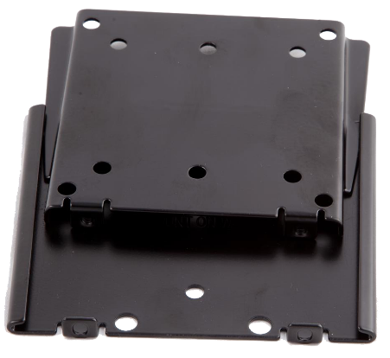
Fig 1.
Wall Mount
Locking Screws

12 Installation Procedure Fig 2

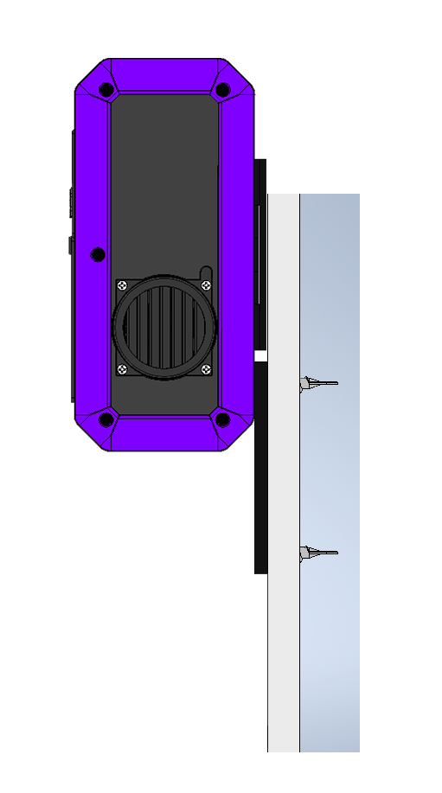
Wall Section of the Vesa Mount
Threaded Anchors
CID 75k Section of the Vesa Mount
Top

Wall

Fig 2.

13 Filter Replacement and Reset Procedure

Filter Location
- Turn the CID 75k off.
- Locate the intake filter housing on the front of the unit. The front grill must be removed to gain access to the filter media.
- Pull on the top outer edges of the grill carefully to remove it as shown in Fig 1A.
- Replace the filter media if dirty as shown in Fig 1B. To determine if the filter can be used for another 30-day cycle, hold the filter up to the light. If light can easily be seen through the filter, it can be used for another 30 days.
- Replace grill by carefully hinging on to the bottom of the housing first and snapping it into place on the top (reverse order of removal).
- Once the filter has been checked and replaced if necessary, power the unit on. The Filter Indicator will still be illuminated red at this point.
- To reset the Filter Indicator, press the Filter LED reset button located on the front of the unit. The Filter Indicator will change from red to green indicating the filter reset procedure has been completed.
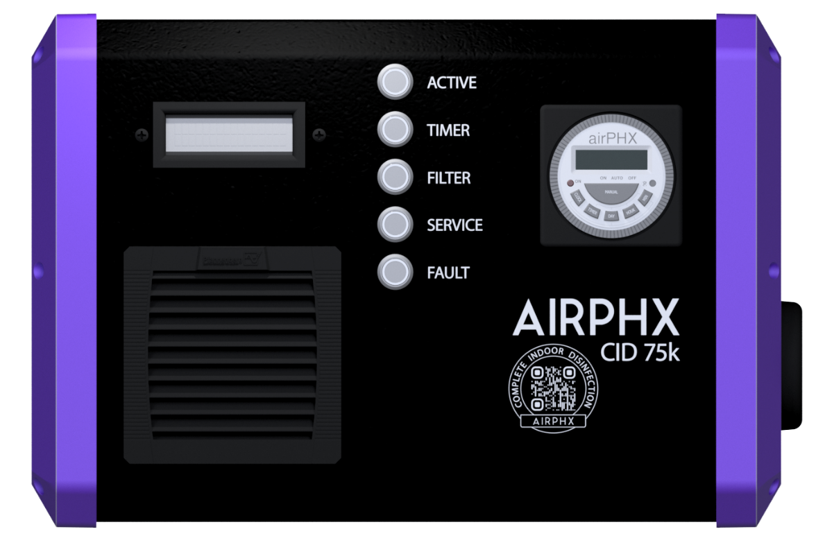
Filter Reset
Button
Intake Filter
Housing
Pull here to remove

14 Filter Replacement and Reset Procedure cont.
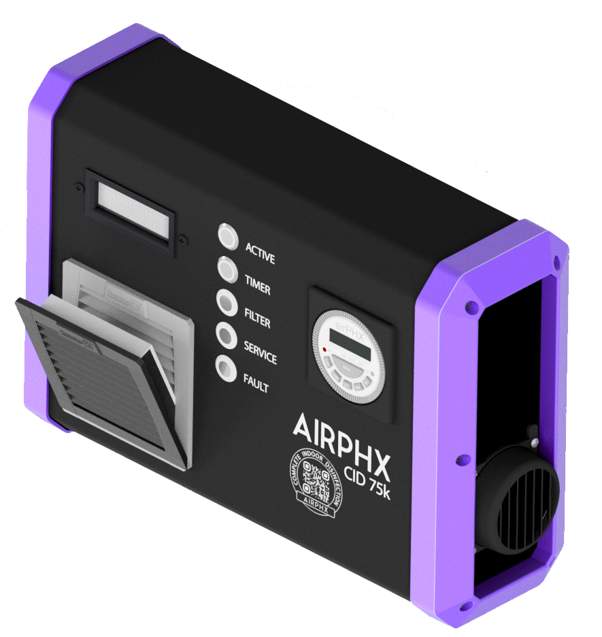

Fig 1A.

15 Filter Replacement and Reset Procedure cont.

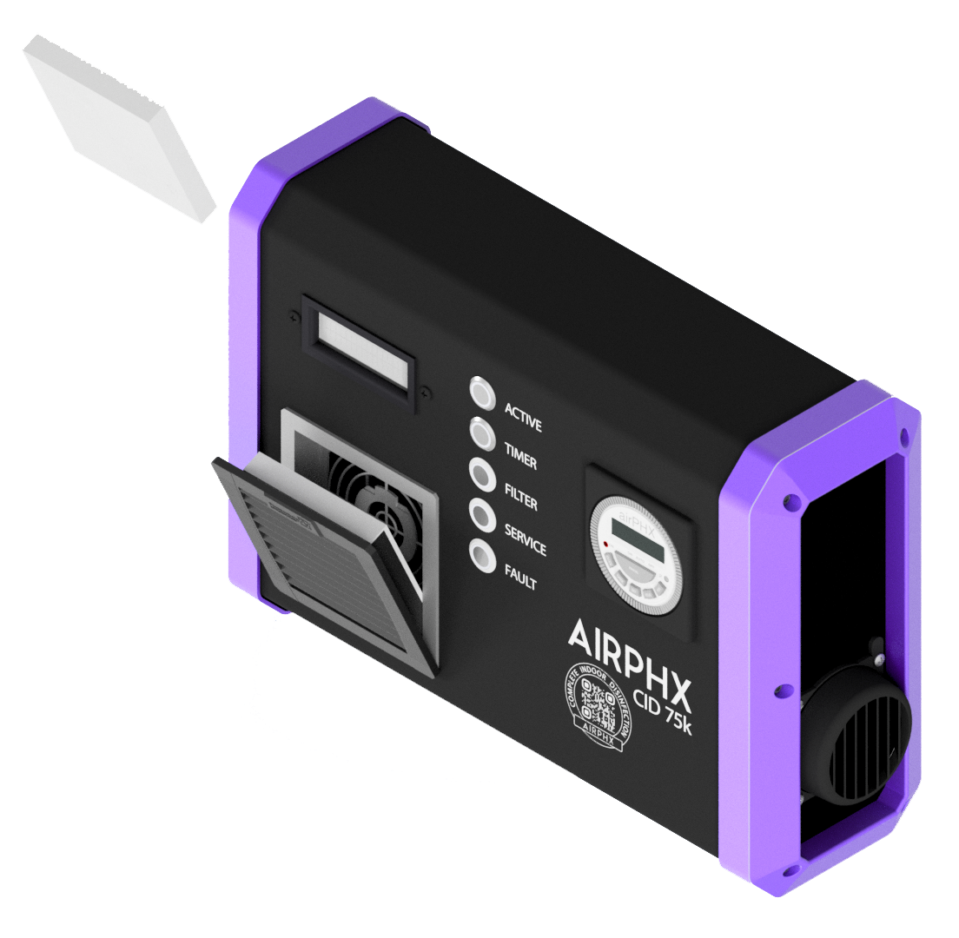

Fig 1B.

16 Plasma Chamber Replacement and Reset Procedure
- Turn the power switch off on the CID 75k.
- Carefully remove the replacement plasma chamber from the box it was shipped in.
Note: The plasma chamber contains a glass element and is very fragile. If the shipping box or plasma chamber looks damaged, please contact your AIRPHX representative for a replacement.
- The plasma chamber is located behind the exhaust grill located on the right side of the unit. This grill must be removed to gain access to the plasma chamber as shown in Fig 1C.
- Using a Phillips screwdriver, loosen and remove all four screws that secure the exhaust grill in place as shown in Fig 1D.
- The end of the plasma chamber (tube) will be exposed once the grill is removed. Grasp the end of the tube and pull it straight out of the unit.
- With the new plasma chamber in hand, align the contacts on the plasma chamber with the two notches in the enclosure, making certain that the label on the plasma chamber is facing towards you as shown in Fig 1E.
- Keep the plasma chamber in a straight orientation as you slide it into the unit. You will feel the plasma chamber come to a stop once it is in its contact socket. Push the plasma chamber in until fully seated.
- Replace the exhaust grill taking note of the alignment of the tab on the grill itself as shown in Fig 1F.

17 Plasma Chamber Replacement Process cont.
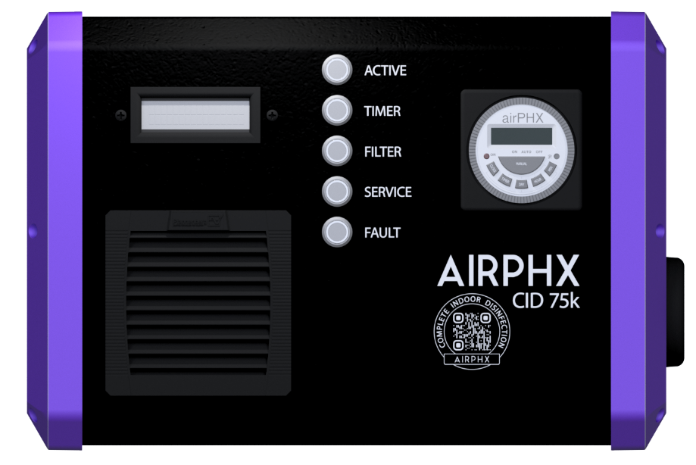
Plasma Chamber Exhaust Grill

Fig 1C.

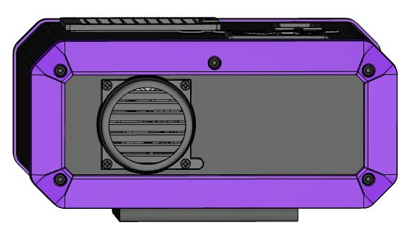
Exhaust Grill Screws

Fig 1D.

18 Plasma Chamber Replacement Process cont.

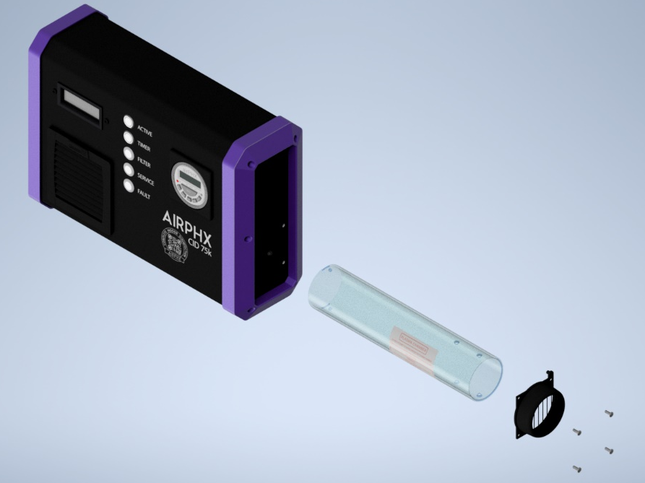

Contacts
Plasma Chamber

Fig 1E.

19 Plasma Chamber Replacement Process cont.

Tab

Fig 1F.

20 Q&A
A number of frequently asked questions about the CID 75k may be found at www.airphx.com/FAQs. Some questions concerning operations are set forth below.
Q – I have plugged the CID 75k into a 120-volt outlet, but the unit will not turn on. What should I do?
A – Verify that the outlet the unit is plugged into has power and that the outlet has the correct voltage.
Q – I powered the CID 75k on for the first time and the Filter Indicator is red and the unit is not running. What do I do?
A – With the unit powered on, press the Filter LED reset button located on the front of the unit for 15 seconds. The Filter Indicator will change from red to green and the unit will startup.
Q – I powered the CID 75k on for the first time and the Display LCD is blank. What do I do?
A – With the unit powered on, press the Fault Indicator to reset the display mode.
Q – What should I do if the Active Indicator is illuminated RED?
A – Check the LCD on the front of the unit. This will display the issue with the unit.
Q – How often do I need to change the filter on the CID 75k?
A – The filter needs to be checked every 30 days and changed if dirty unless otherwise specified. The Filter Indicator will illuminate red after 30 days of operation. Please note that the CID 75k will go into standby if the filter is not checked within 15 days of the Filter Indicator illuminating red. Please refer to the section in this guide Filter Replacement and Reset Procedure for further information.
Note: The frequency for replacing the filter can be increased (e.g. every 15 days) if the filter is found to be very dirty at the 30-day mark. Please keep in mind that the Filter Indicator cycle is set for 30 days and cannot be changed. If the filter needs to be changed sooner, it is recommended it is done so consistently.

21 Q&A cont.
Operation cont.
Q – What is standby?
A – Standby is when the CID 75k stops and the turbine is shut off. The unit is silent and appears to be off, but the unit is in fact powered on and waiting for a condition to clear in order to resume operation.
Conditions that can cause the CID 75k to go into standby:
The 7 Day Timer is in an off schedule.
The filter needs to be checked and the Filter Indicator has been red for 15 days.
The Service Indicator has illuminated red.
The unit has detected a fault.
Q – Where is the CID 75k manufactured?
A – The CID 75k is manufactured in the United States.
Q – What is the proper sized space to operate a CID 75k?
A – The CID 75k is intended to treat areas with 75,000 cubic feet of air with good air circulation assuming a bio-burden customary for occupied spaces. If the CID 75k is operated in smaller spaces, the unit should be run using the timer to reduce the amount of oxidizing molecules being released.
Q – Do I have to wall mount the unit?
A – The CID 75k is designed to be mounted on a wall.

Warranty
PRODUCT WARRANTY. 1 YEAR ON ALL PARTS OTHER THAN THE PLASMA CHAMBER (6 MONTH WARRANTY); 1 YEAR ON LABOR FROM THE DATE OF PURCHASER INVOICE. AT AIRPHX’S OPTION, AIRPHX MAY REPAIR OR REPLACE THE PRODUCT.
PHOENIXAIRE, LLC (dba AIRPHX) EXPRESSLY WARRANTS ALL NEW PRODUCTS TO BE FREE FROM DEFECTS IN MATERIALS AND MANUFACTURE FOR THE WARRANTY PERIODS SET FORTH ABOVE. THE WARRANTY PERIOD COMMENCES ON THE INVOICE DATE ON THE ORIGINAL PURCHASE. THIS WARRANTY APPLIES ONLY AGAINST DEFECTS DISCOVERED WITHIN THE WARRANTY PERIOD AND EXTENDS ONLY TO THE ORIGINAL PURCHASER OF THE PRODUCT. ONLY PARTS, REPAIRS, MODIFICATION AND/OR MAINTENANCE SUPPLIED BY AN AIRPHX REPRESENTATIVE, UNDER THE TERMS OF THIS WARRANTY, WILL BE WARRANTED FOR THE REMAINDER OF THE ORIGINAL WARRANTY PERIOD. TO PROCESS A CLAIM UNDER THIS WARRANTY, THE PURCHASER MUST NOTIFY AIRPHX IN WRITING OR BY FAX WITHIN 30 DAYS AFTER THE DISCOVERY OF THE ALLEGED DEFECT AND MAKE THE PRODUCT AVAILABLE FOR INSPECTION BY AN AIRPHX REPRESENTATIVE. FAILURE TO TIMELY AND PROPERLY NOTIFY AIRPHX IN WRITING OR BY FAX WILL RESULT IN NULLIFICATION OF THIS WARRANTY.
ANY PARTS, REPAIRS, MODIFICATION AND/OR MAINTENANCE SUPPLIED BY A NON-AIRPHX REPRESENTATIVE (OTHER THAN AIRPHX RECOMMENDED ROUTINE MAINTENANCE) VOIDS THE ENTIRE WARRANTY FOR THIS DEVICE.
NO OTHER EXPRESS WARRANTY IS GIVEN WITH THE PURCHASE ORDER AND AIRPHX DISCLAIMS ANY AUTHORITY FOR ANY EMPLOYEE OR AGENT TO PROVIDE OR MAKE ANY OTHER WARRANTY OF ANY KIND WHETHER IN WRITING OR ORALLY.
This warranty is valid only in accordance with the conditions set forth below:
- The warranty applies to the AIRPHX product only while
- Title and possession remain in the original purchaser and proof of purchase is demonstrated,
- It has not been subjected to casualty, misuse, abuse, service or modification performed and not authorized by an AIRPHX representative,
- Claims are made timely and properly within the warranty period by written notice or fax (within 15 days of the applicable warranty period).
- This warranty does not cover damage or equipment failure caused by any type of electrical surge and/or failure to adhere to AIRPHX Operating Instructions and Care and Cleaning Instructions.
- Except in Canada, AIRPHX does not pay labor outside of the United States.
- Warranties outside the United States and Canada may vary. Please contact your local Dealer for details.
This limited warranty shall not apply to:
- Cosmetic items.
- Repairs performed on AIRPHX equipment missing a serial number or with a serial tag that has been altered or defaced.
- Service calls to correct installation of the equipment or instruct the owners on how to use the equipment.
- Pickup, delivery, or freight charges involved with repairs.
- Any labor costs incurred beyond the applicable labor warranty period.
- Any equipment that has had the end caps removed by any person other than an AIRPHX representative.

Disclaimer
The express warranties provided herein are the exclusive warranties given by AIRPHX and supercede any prior, contrary or additional representation/warranties, written or oral. ANY IMPLIED WARRANTIES, INCLUDING THE WARRANTY OF MERCHANTABILITY AND/OR FITNESS FOR A PARTICULAR PURPOSE THAT APPLY TO ANY PARTS DESCRIBED ABOVE ARE LIMITED IN DURATION TO THE PERIODS OF EXPRESS WARRANTIES GIVEN ABOVE FOR THOSE SAME PARTS. AIRPHX HEREBY DISCLAIMS AND EXCLUDES THOSE WARRANTIES THEREAFTER. SOME STATES DO NOT ALLOW LIMITATION ON HOW LONG AN IMPLIED WARRANTY LASTS, SO THE ABOVE LIMITATION MAY NOT APPLY TO YOU. AIRPHX ALSO HEREBY DISCLAIMS AND EXCLUDES ALL OTHER OBLIGATIONS OR LIABILITIES, EXPRESS OR IMPLIED ARISING BY LAW OR OTHERWISE WITH REGARD TO ANY NONCONFORMANCE OR DEFECT IN ANY PRODUCT, INCLUDING BUT NOT LIMITED TO: (A) ANY OBLIGATION, LIABILITY, RIGHT, CLAIM, OR REMEDY IN TORT, WHETHER OR NOT ARISING FROM THE NEGLIGENCE OF AIRPHX OR ITS SUPPLIERS (WHETHER ACTIVE, PASSIVE OR IMPUTED) AND (B) ANY OBLIGATION, LIABILITY, RIGHT, CLAIM OR REMEDY FOR LOSS OF OR DAMAGE TO ANY EQUIPMENT. THIS DISCLAIMER AND RELEASE SHALL APPLY EVEN IF THE EXPRESS WARRANTY SET FORTH ABOVE FAILS IN ITS ESSENTIAL PURPOSE.
Exclusive Remedies
For any product described above that fails to conform to its warranty, an AIRPHX representative will exclusively provide repairs provided the equipment has not been subject to casualty, misuse, abuse, service or modification performed and not authorized by an AIRPHX representative. Service must be obtained by calling AIRPHX at 1 (855) 4 AIRPHX / 1 (855) 424-7749. THESE SHALL BE THE SOLE AND EXCLUSIVE REMEDIES OF THE BUYER FOR ANY BREACH OF WARRANTY.
AIRPHX AND/OR ITS SUPPLIERS, DEALERS AND DISTRIBUTORS SHALL HAVE NO OBLIGATION OR LIABILITY, WHETHER ARISING IN CONTRACT (INCLUDING WARRANTY), TORT (INCLUDING ACTIVE, PASSIVE, OR IMPUTED NEGLIGENCE AND STRICT LIABILITY), OR OTHERWISE, FOR DAMAGE TO THE EQUIPMENT, PROPERTY DAMAGE, LOSS OF USE, REVENUE OR PROFIT, COST OF CAPITAL, COST OF SUBSTITUTE EQUIPMENT, ADDITIONAL COSTS INCURRED BY BUYER (BY WAY OF CORRECTION OR OTHERWISE) OR ANY OTHER INCIDENTAL, SPECIAL, INDIRECT, OR CONSEQUENTIAL DAMAGES, WHETHER RESULTING FROM NON-DELIVERY OR FROM THE USE, MISUSE OR INABILITY TO USE THE PRODUCT. THIS EXCLUSION APPLIES EVEN IF THE ABOVE WARRANTY FAILS OF ITS ESSENTIAL PURPOSE AND REGARDLESS OF WHETHER SUCH DAMAGES ARE SOUGHT FOR BREACH OF WARRANTY, BREACH OF CONTRACT, NEGLIGENCE, OR STRICT LIABILITY IN TORT OR UNDER ANY OTHER LEGAL THEORY.

